**ML Model deployment using flask in docker:**

**Dataset:** Insurance Dataset

**Algorithm:** Linear Regression

**Tools**: Visual studio code, Docker Engine.

**Framework:** Flask

**Sequence of steps:**

* Create a folder on desktop (ex: ML_Flask)
* Open VS Code -> open that folder which was we created on desktop
* In that folder create sub folder, named it as templets
* Put index.html file into the templates folder, we must create templates folder because this html code is redirected to the render templates python library.

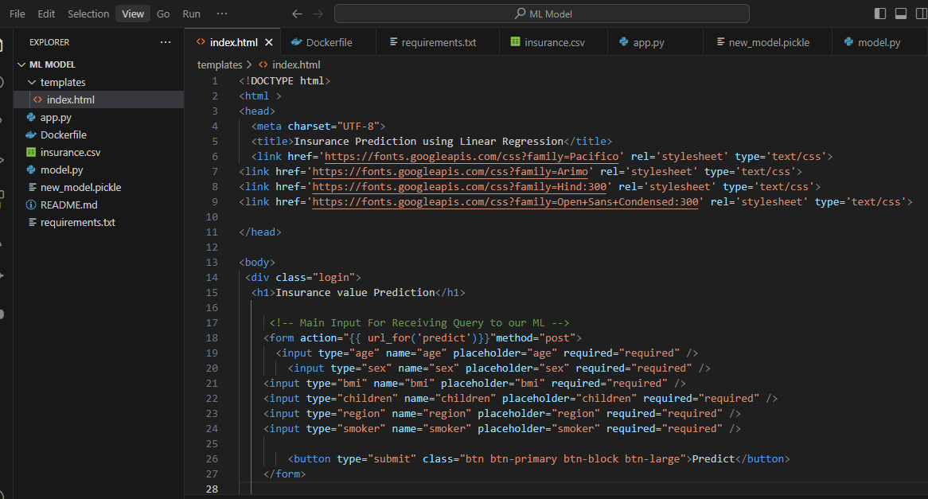

* Create an ML model using Linear Regression algorithm on insurance dataset and saved it in pikel format in model.py file.

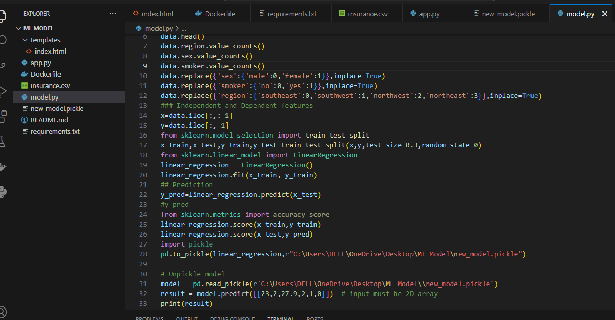

* The model is saved model file is new_model.pkl file, this file is loaded and read by the pickle.

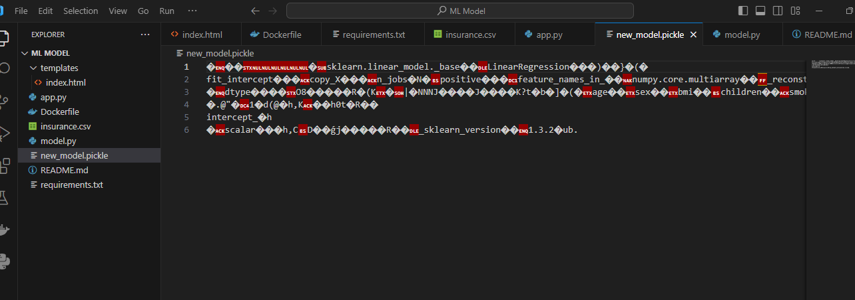

* Now import the insurance dataset in VS code for model building.

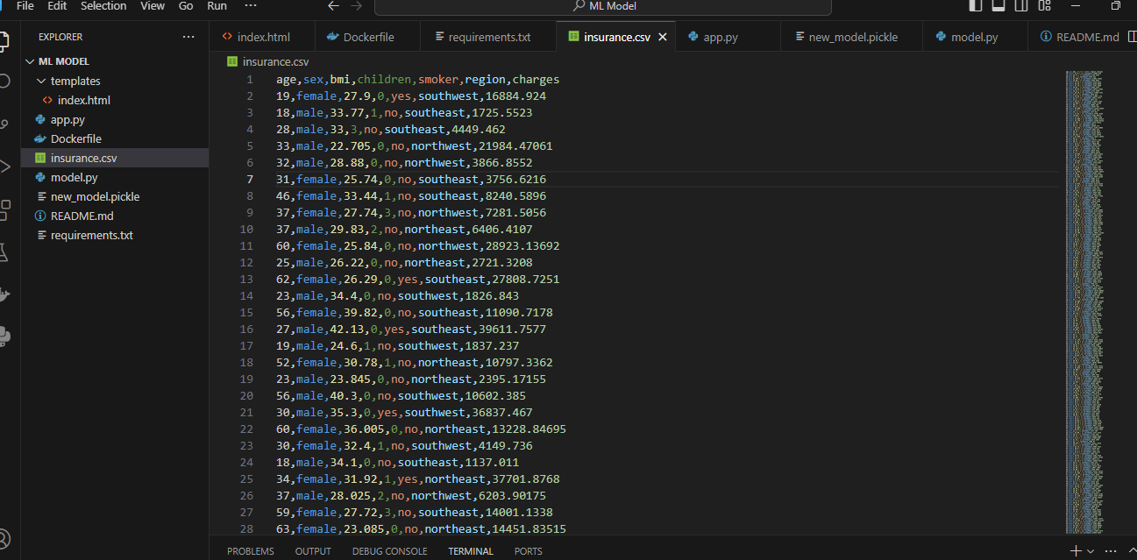

* Now integrated the ML model with flask in app.py it was called the model pickle file and index html file for integration to create web page.

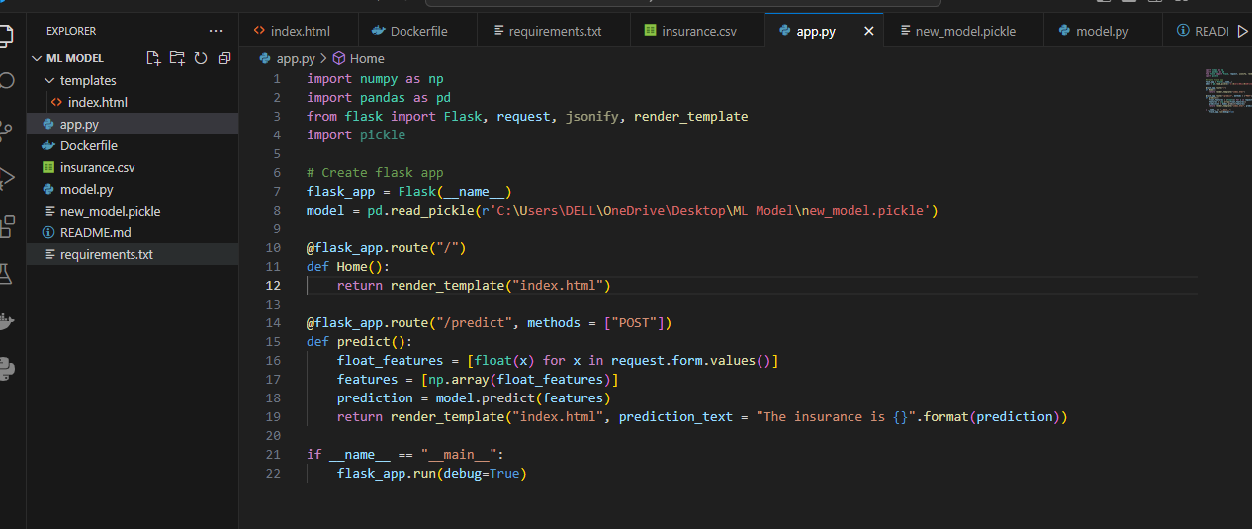

* Now execute in the terminal of vs code the-> python app.py command it gave web page.

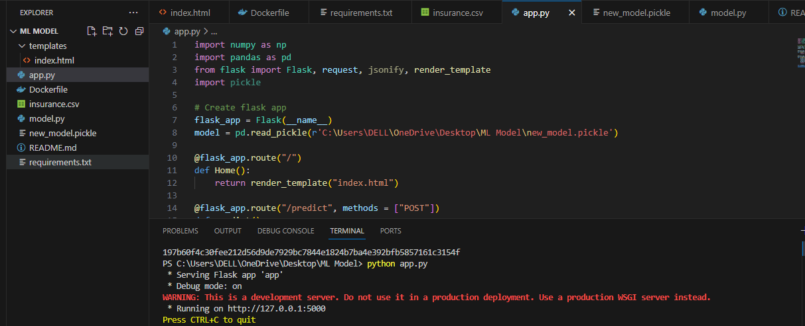

* Now copy paste the HTTP URL on web browser. We got ml flask application, next enter the input values click on predict it will give the predicted amount of insurance based on input features.

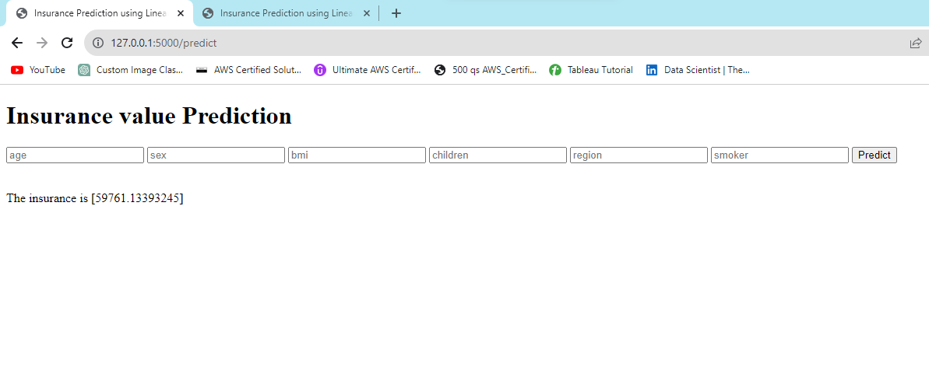

* Now it’s time to containerize the flask ml application using Docker engine.
* Create Dockerfile in vs code using the following code.

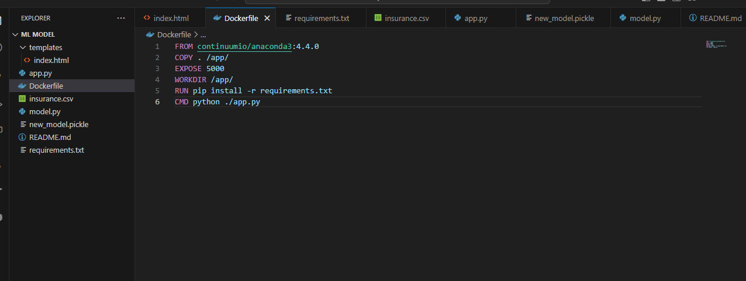

* Create requirements.txt file in the we need to write all libraries we need to install.

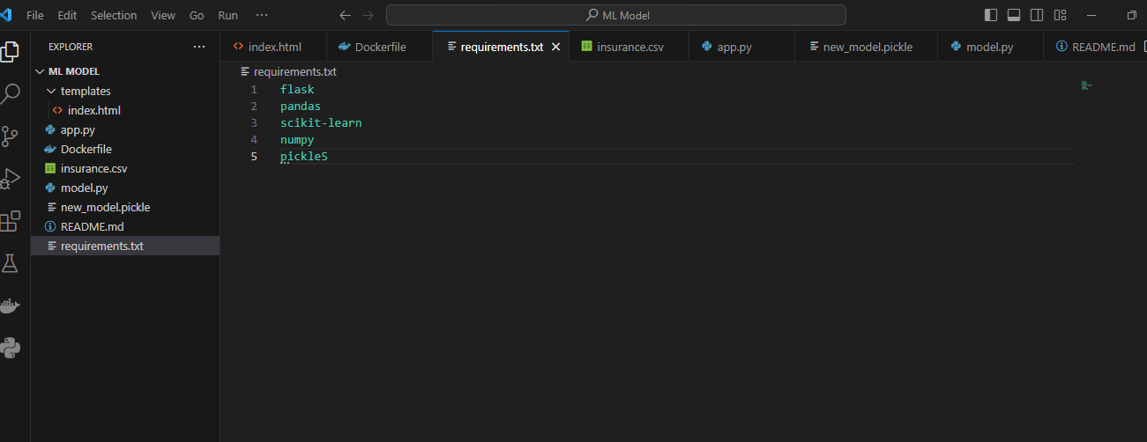

* Now it’s time to build docker image and start it for that go to the ->vs terminal-> run new terminal-> (type) docker build –t name .

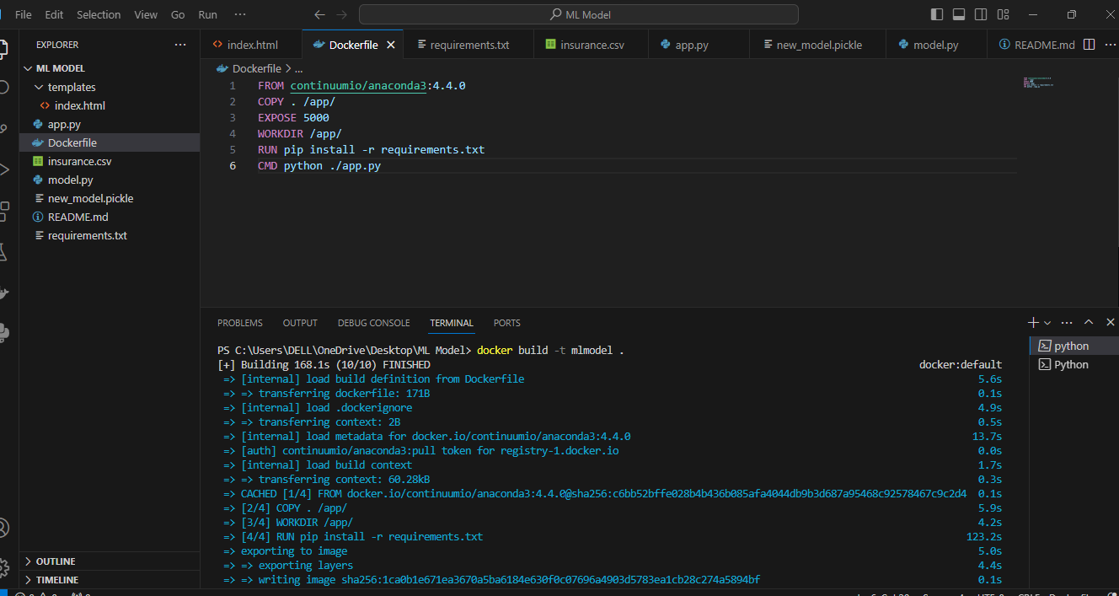

* After building an image without any errors, now run the docker image using command: docker run –d –p port:port name

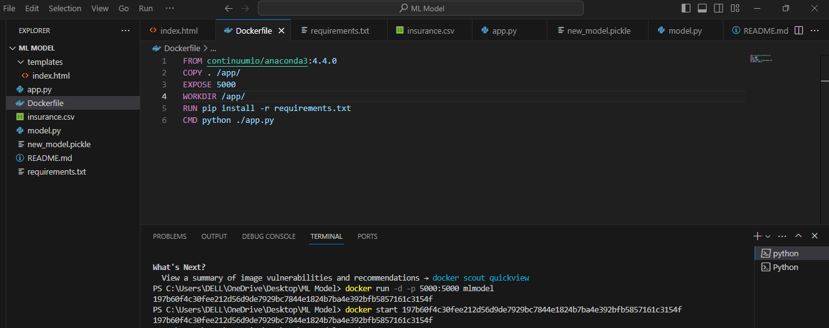

* After running this, you got a string ID, now type docker start ID (copy/paste).
* Now go to web browser type localhost: port you will get a web application for our ML model.

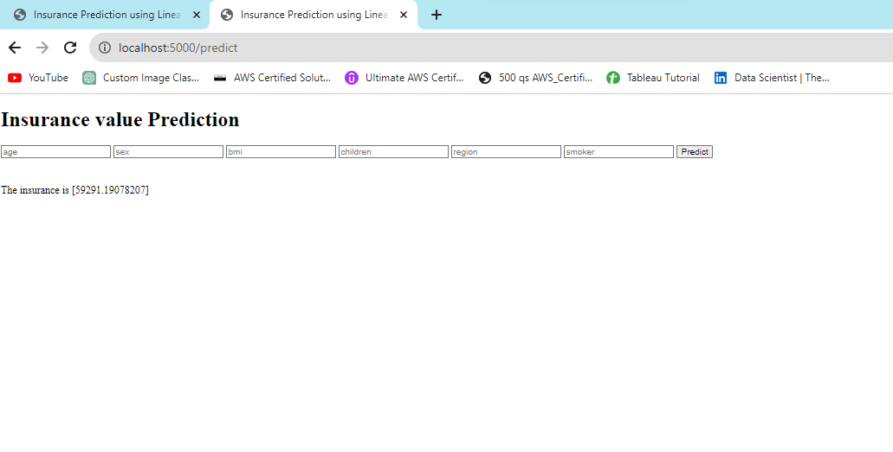

* Simultaneously check out the docker engine in that container also running.
* In this web server we are predicting insurance values with unknown inputs.

**Thank you.**

**Karuna.V**